Chapter 19, Solution 39.

We obtain g₁₁ and g₂₁ using the circuit below.

I₁ R₁ R₃ I₂=0
+
_

+

R₂
V₁ V₂

–

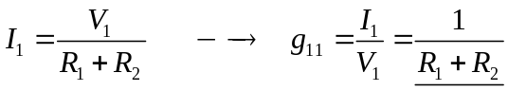

By voltage division,
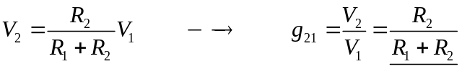

We obtain g₁₂ and g₂₂ using the circuit below.

I₁ R₁ R₃

+ +

R₂ I₂
V₁=0 V₂

– –

By current division,
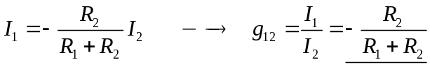
Also,
